Case 1: Sales Performance Analysis
Company Background
TechSupply Co. is a regional distributor that sells electronics, office supplies, and office furniture to both retail and business customers. Management wants to better understand sales trends, customer purchasing behavior, and regional performance to improve future sales strategies.
You have been hired as a junior data analyst to explore the sales dataset and provide insights. Your task is to use Excel filtering and sorting tools to answer business questions and provide recommendations.
Dataset: use the techsupply_dataset.xlsx
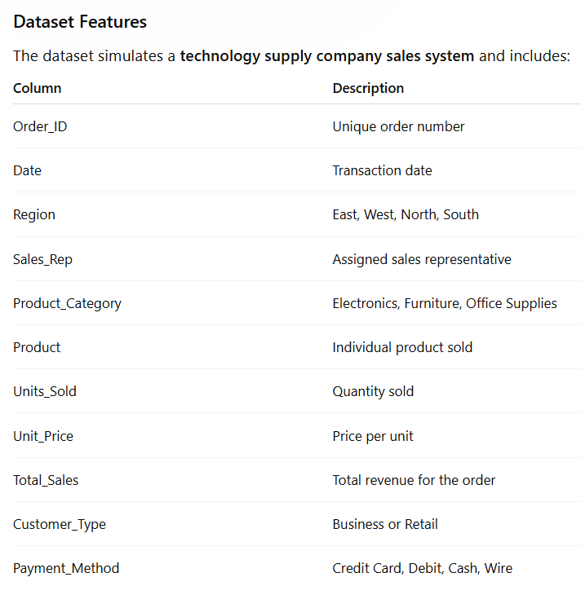

Complete the following 5 tasks.
REGIONAL PERFORMANCE ANALYSIS
Task 1: Use filters to explore sales by region.
- Filter by Region = East
Brown and Johnson appear most often in the East region, with 13 orders each.
- Sort Total_Sales from Largest to Smallest
Questions:
- What is the largest sale in the East region? $52,950.00
- Which product category appears most frequently? Electronics with 33 orders.

Which sales representative appears most often? Brown and Johnson appear most often in the East region, with 13 orders each.

CUSTOMER BEHAVIOR ANALYSIS
Task 2: Filter by
- Customer Type = Business
Questions
- Which product category do business customers purchase most often?
- What is the largest business transaction? The largest business transaction is $63,646.20.
- Which sales rep handles the most business orders? Brown and Garcia handle the most business orders, with 25 orders each.
PRODUCT PERFORMANCE
Task 3: Use filters to analyze Product Category.
Analyze each category separately:
- Electronics
- Furniture
- Office Supplies
Questions
- Which category appears to generate the highest total sales? Furniture generates the highest total sales, at approximately $1.29 million.
- Which specific product appears most frequently? Filing Cabinet, Notebooks, and Printer Paper appear most frequently, with 26 orders each.
- Which category tends to have the largest individual transactions?
PAYMENT PATTERN ANALYSIS
Task 4: Filter by Payment_Method
Analyze:
- Credit Card
- Debit
- Cash
- Wire
Questions
- Which payment method is used most frequently? Credit Card is the most frequently used payment method, with 88 orders.
- Do business customers prefer a specific payment type? Business customers use Debit most often, with 48 orders.
- Which payment type is associated with larger purchases? Wire payments are associated with larger purchases, with the highest average transaction value of $10,812.79.
TOP SALES REPRESENTATIVES
Task 5: Sort by:
- Sales_Rep
- Total_Sales(Largset > Smallest)
Questions
- Which sales rep appears to handle high-value transactions? Garcia handles high-value transactions, including the dataset’s largest sale of $75,929.88.”
- Which rep appears most frequently in the dataset? Brown appears most frequently in the dataset, with 45 orders.
- Which region do they appear to sell in most often? Brown sells most often in the West region, with 15 orders.
ANALYST RECOMMENDATION
Imagine you are presenting your findings to management.
Answer the following:
- Which region appears to be the strongest market? The East region appears to be the strongest market because it has the highest total sales, approximately $582,612.”
- Which product category should the company promote more? The company should promote Furniture more because it generated the highest total sales, approximately $1.29 million.
- Are business customers or retail customers more valuable? Retail customers are more valuable based on sales revenue. They generated higher total sales and a higher average sale than business customers.
- What two recommendations would you give the sales manager? I recommend promoting furniture in East and South, the two strongest regions. I also recommend testing offers for retail customers because they have a higher average purchase value.

Bonus
Build
- Bar Chart – Sales by Product Category
- Pie Chart – Customer Type Distribution
- Column Chart – Sales by Region
What story does the data tell?
Furniture generated the most sales revenue, followed by electronics. East had the highest regional sales, slightly ahead of South, while West had the lowest. Business customers placed 54% of orders, compared with 46% for retail customers. However, retail customer generated more total revenue and had a higher average purchase value.

